**DECLARATION**

We certify that this project does not in incorporate without acknowledgement any material previously submitted for a diploma in Institute and to the best of our knowledge and belief it does not contain any material previously published or written by another person or our self except where due reference is made in the text. We also here by giving consent for our project report if accepted to be made available for photocopying.

* KARUNARATHNE T.N. (MS) –………………
* KKUMARASIRI P.A.H.D. (MS) –…………….
* DABARE P.R.D. (MR) –…………….
* WIMALASENA K.C.G (MR) – ………….
* LAKSHAN K.A.R. (MR) – ………….
* HEWAWITHARANA H.V.S.M. (MR) –……….

**ACKNOLEDGEMENT**

First, we would like to express out heart full of gratitude to National Institute of Business Management for giving this challenge the opportunity and support, which rendered us the physical strength and pleasant mind to complete this work.

It is a great pleasure that we participated the course 16.3 at NIBM takes the task of materializing the project, which we wish to thank all who helped us in many ways for this project to complete with success. We thanked Mrs. Nilani who teaches Database Management to us, giving introduction and valuable advices always.

In addition, we regard the Mr. Lakshman Wanniachchi owner of Chemwood Export

(Pvt) Limited Meegoda, Mr. Sanka Wanniachchi the Manager of the company, Mrs. Dhammika Wickramasinghe, Mrs. Kalpana Wijewardhana Staff members of above company for giving their previous time and hand to all of us.

We like to thank to Instructions who are work at the NIBM to giving advices to us.

Further we would like to extend our thanks and gratitude to our parents, friends, those who helped us directly and indirectly for the successful completion of this project work.

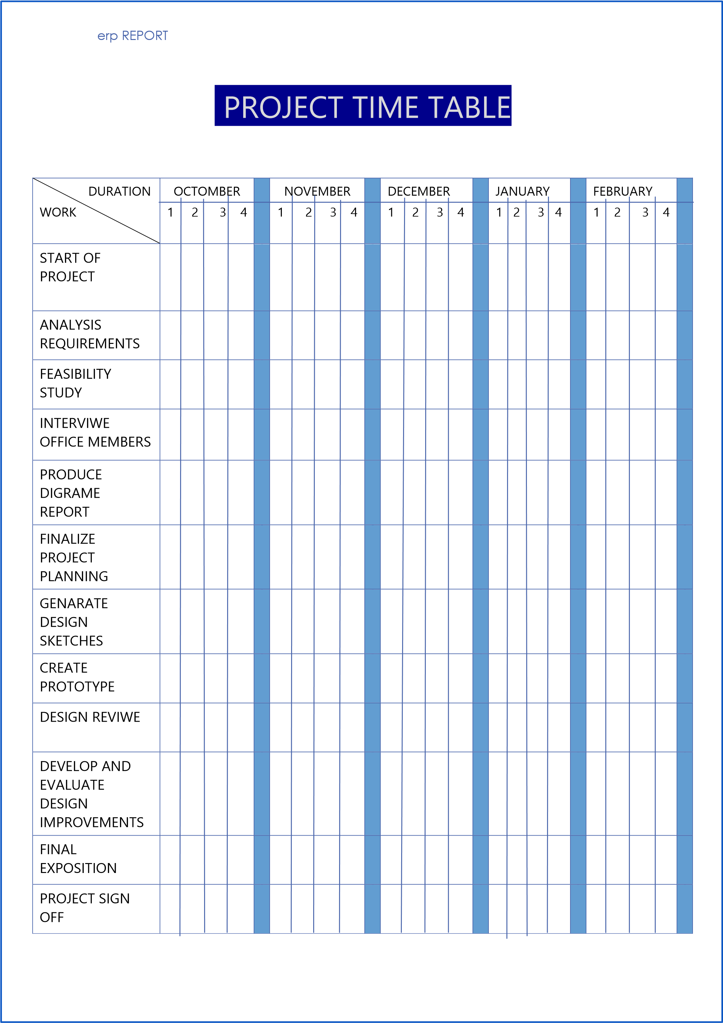**PROJECT TIME TABLE**

**scope of study**

The scope of study consists of understanding the current non-computerized system and we eliminate the main drawbacks and identified the benefits of current system. We studied their major function including item ordering, purchase orders, handling, supplier detail handling, and purchase return handling.

**Contents**

1.Summary of report

2.Objectives of preparing database

3. The current system

4. Problems in occurrence system

5. Process-context level diagram

6. Advantages of proposed system

7. Disadvantage of proposed system

8. Entity relationship diagram

9. Proses 1st level diagram

10. List of relations

11. Propose option

12. Mapping entity and relations with assertions

1. **summary of report**

The Chemwood Export (Pvt) Ltd. where we get information requested us to develop a computer based sales inventory control system, which was at the point of manually.

After detailed investigation of the manual system we are designed a system to the best of our ability, which would after the company’s needs, a brief description of the proposed system analysis for the development of the software are included here.

1. **OBJECTIVES OF PREPARING DATABASE**

* Fast and easy data recording.
* Efficient reverse lookup to retrieve data faster and easily.
* Automated preparation of employee and manufacturing history.
* To save time and cost.

1. **THE CURRENT SYSTEM**

* Manual non-computerized system.
* Customers who place orders are given their details to the office register.
* Each unit are maintaining by office, they maintain data, and it consists each details.
* Annual serial
* Monthly serial production
* Name of employee
* Age
* Gender
* Employee no
* Address
* Rate of employee
* Manufacturing item
* Item code
* Quantity of manufacturing per
* once
* Value of item
* Name of supplier
* Supply item
* Name of customer
* Contact no

When the customer place order each customer will be registering at the office and office giving them a customer no to continue follow ups. All the above works are done by manually.

1. **PROBLEMS IN CURRENCE SYSTEM**

**Main issue** - Although all documents are placed in stack without a staff member anyone cannot find correct document on time. When comes a new staff member to the office he/she faced difficulties during doing their work as cannot find the files properly.

**Results** - Staff has to waste their many time to finding files.

**Secondary issue –**

1. Takes a lot of time and effort to find previous records of the employee/ item/ customer, from the file stack even if they are named.
2. When customer needs, an item manufactured in long time ago, new staff members can’t recognize it directly without seen past documents and it will be hardest thing to find photography through rhea old documents.
3. When in emergency case like fire documents cannot protect.
4. At some time, documents may be damage with bugs, ants and rats.
5. Staff have to open many files on their tables to find same thing to confirm exactly.
6. At some time, the office looks-like a mass to the visitor.
7. **PROCESS-CONTEX LEVEL DIAGRAM**

**Employee**

**Supplier**

Payment

Customer details

Customer order

Recept

Purchasing Details Details

Details

Supplier Details

**S a l e s I n v e n t o r y c o n t r o l**

Daily report

Details

Details

Price details

Details

Details

Segregted amount

Details

Details

**Management**

**Employee**

1. **ADVANTAGES OF PROPOSED SYSTEM**

* Reduce of manpower
* Reduce space storage
* Reduced time for registration
* Protect from insects
* High security
* Reliable

1. **DISADVANTAGE OF PROPOSED SYSTEM**

The users who logged in to the system can change the real information directly without a problem.

1. **ENTITY RELATIONSHIP DIAGRAM**
2. **PROCESE 1ST LEVEL DIAGRAM**
3. **LIST OF RELATIONS**

* Company (Register_No, Company_Tele,

Company_Name,Website)

* Department (Department_ID)
* Stocks_Mainrow_Metirial (Stock_ID, Name,Value, Quntity,Stock_Type)
* Finish_Good_Meterial (Stock_ID, Name Value,Quantity,Color,Stock_Type)
* Employee (Employee_ID ,NIC_No ,Employee_Name, Date_of_Birth, Employee_Tele , Address, Civil_Status, Gender,Register_No)
* Employee_Skill (Employee_ID ,Skill_Type)
* Payment (Payment_ID, Payment_date, Payment_title, Payment_type)
* Purchase(Payment_ID,Purches_No)
* Salary (Payment_ID,Basic)
* Machine (Machine_ID,Machine_type,Quntity, Register_No)
* Customer (Customer_ID,Customer_type, Customer_tele,Payment_type,Register_No)
* Item (Item_ID, Quantity, Value,Register_No)
* Order(Order_ID,Order_Title,Order_Type,Order_date,Delivery_Type,Delivery_date,Register_No)
* Good (Good_ID,Good_Name)
* Supplier (Supplier_ID,Supplier_name, Supplier_Tel,Supplier_address,Distributer’s_name, Distributer’s_tel,Register_No)
* Gift item (Promotion_ID, Gift_No, Promotion_Value, Promotion_Type, Duration, Gift_Name, Gifted_To,Register_No)
* Advertising (Promotion_ID, Advertising_No,Promotion_Value, Promotion_Type, Duration, Advertising_type, Register_No)

**PROPOSE OPTION**

Few screen shots of the design of proposed system.

1. Create Database

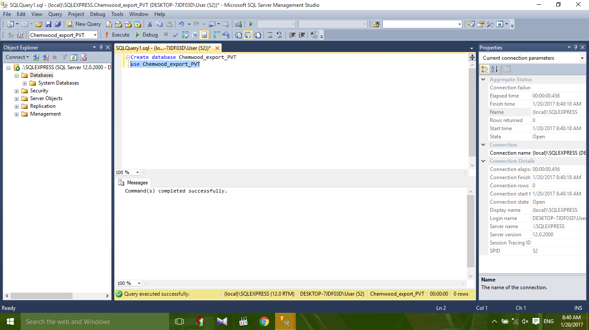

1. 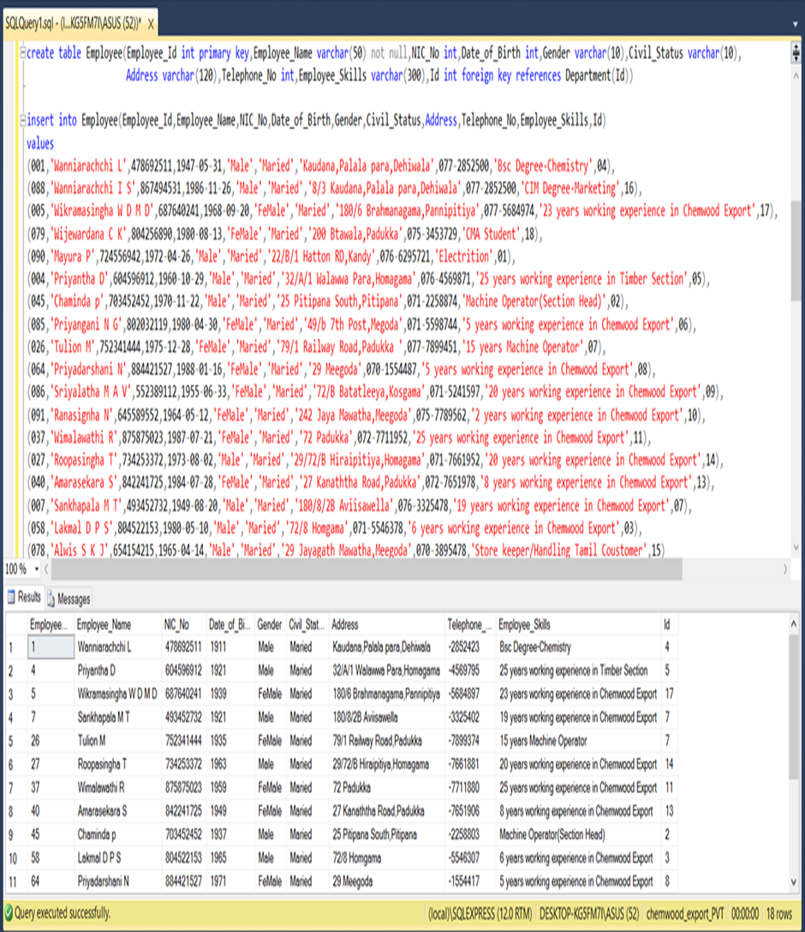Employee Table
2. 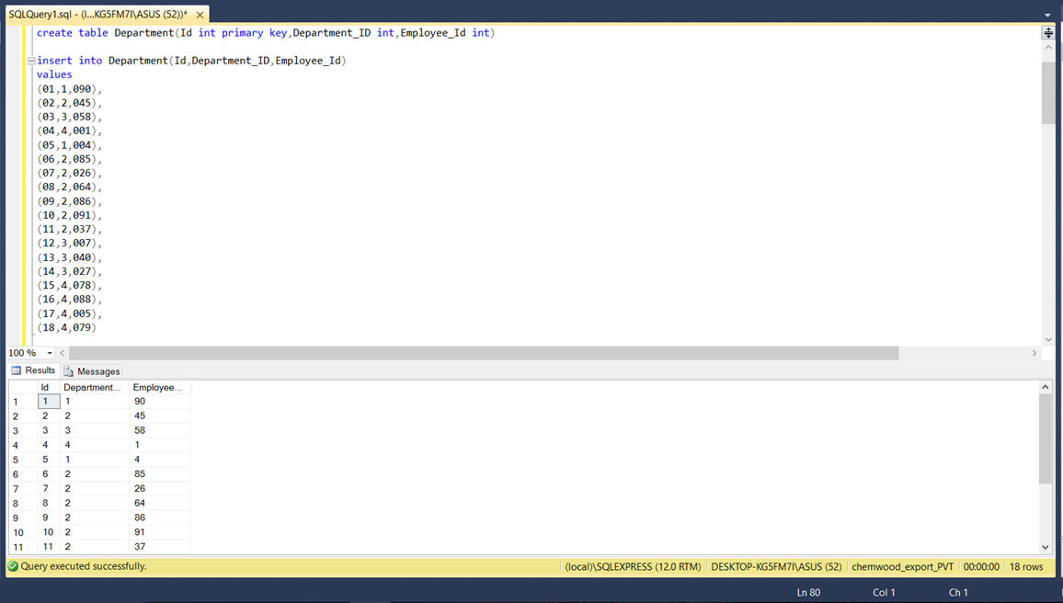Department Table
3. 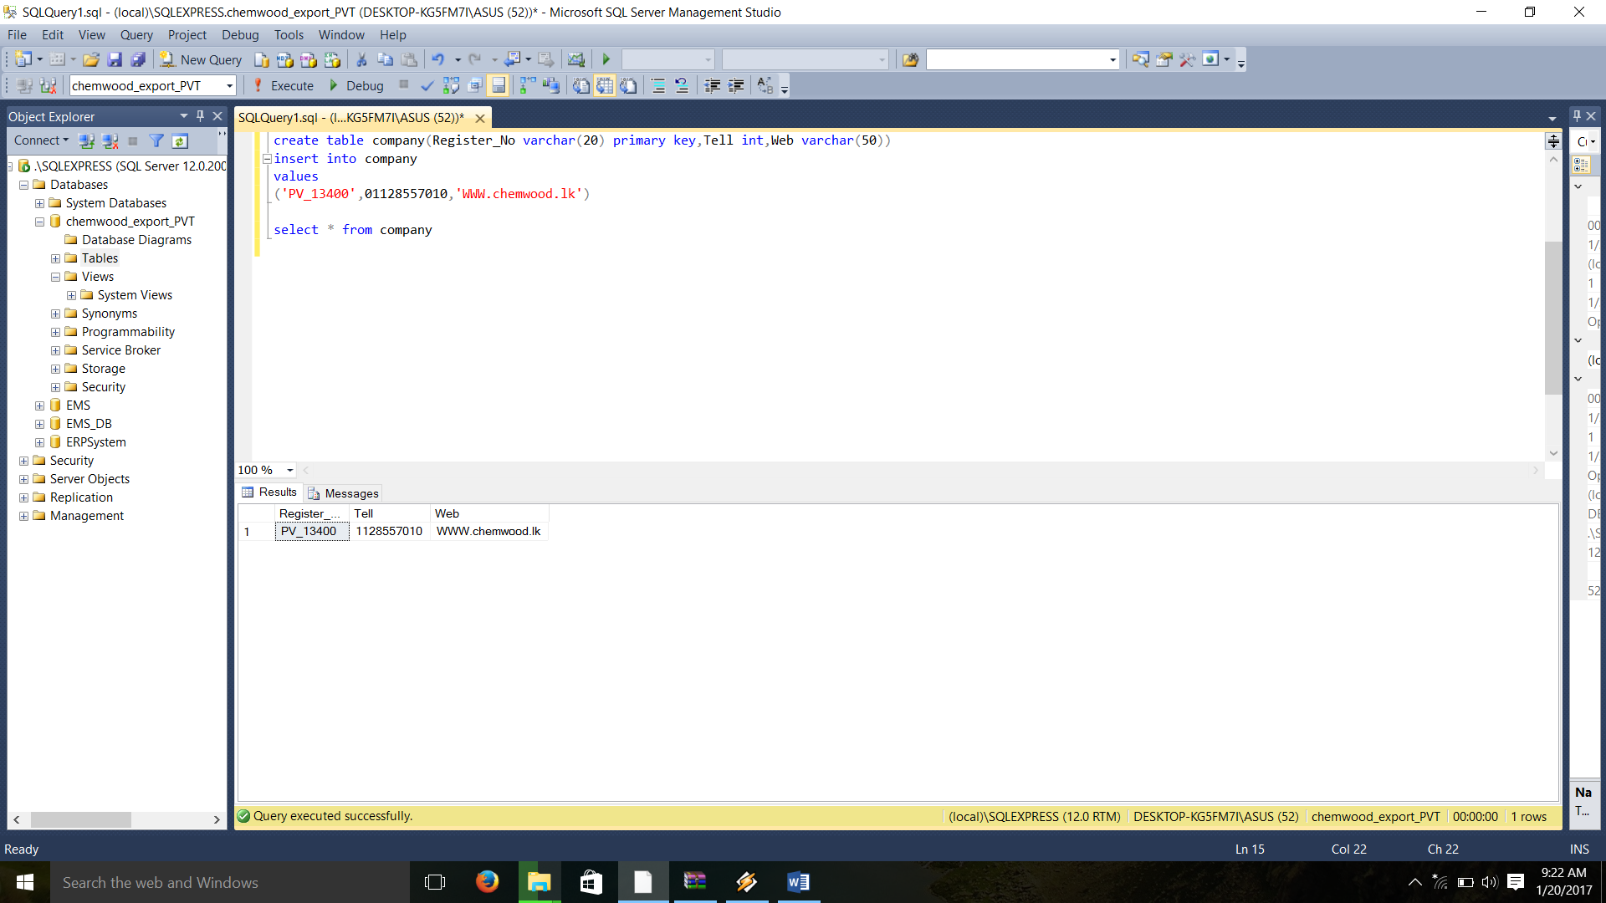Company Table
4. Stocks_mainrow_material

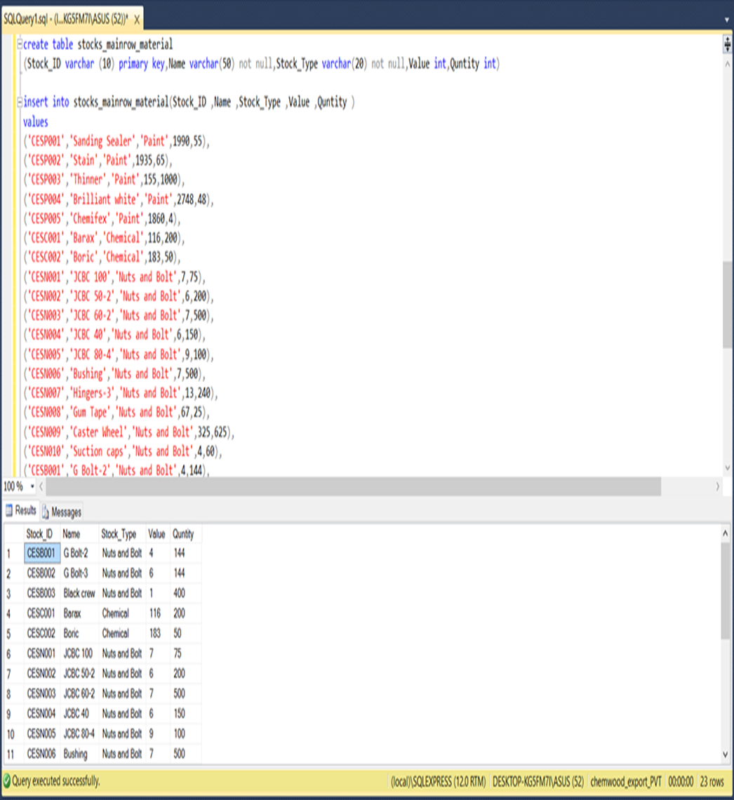

1. Finish_Good_Metirial

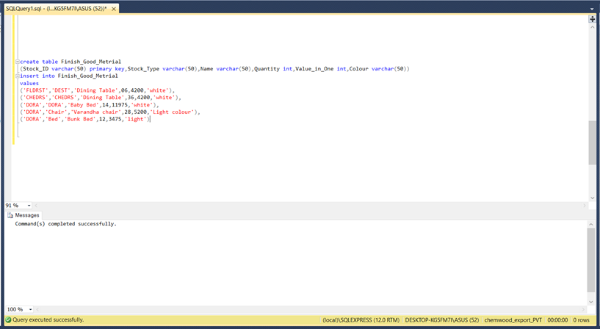

1. 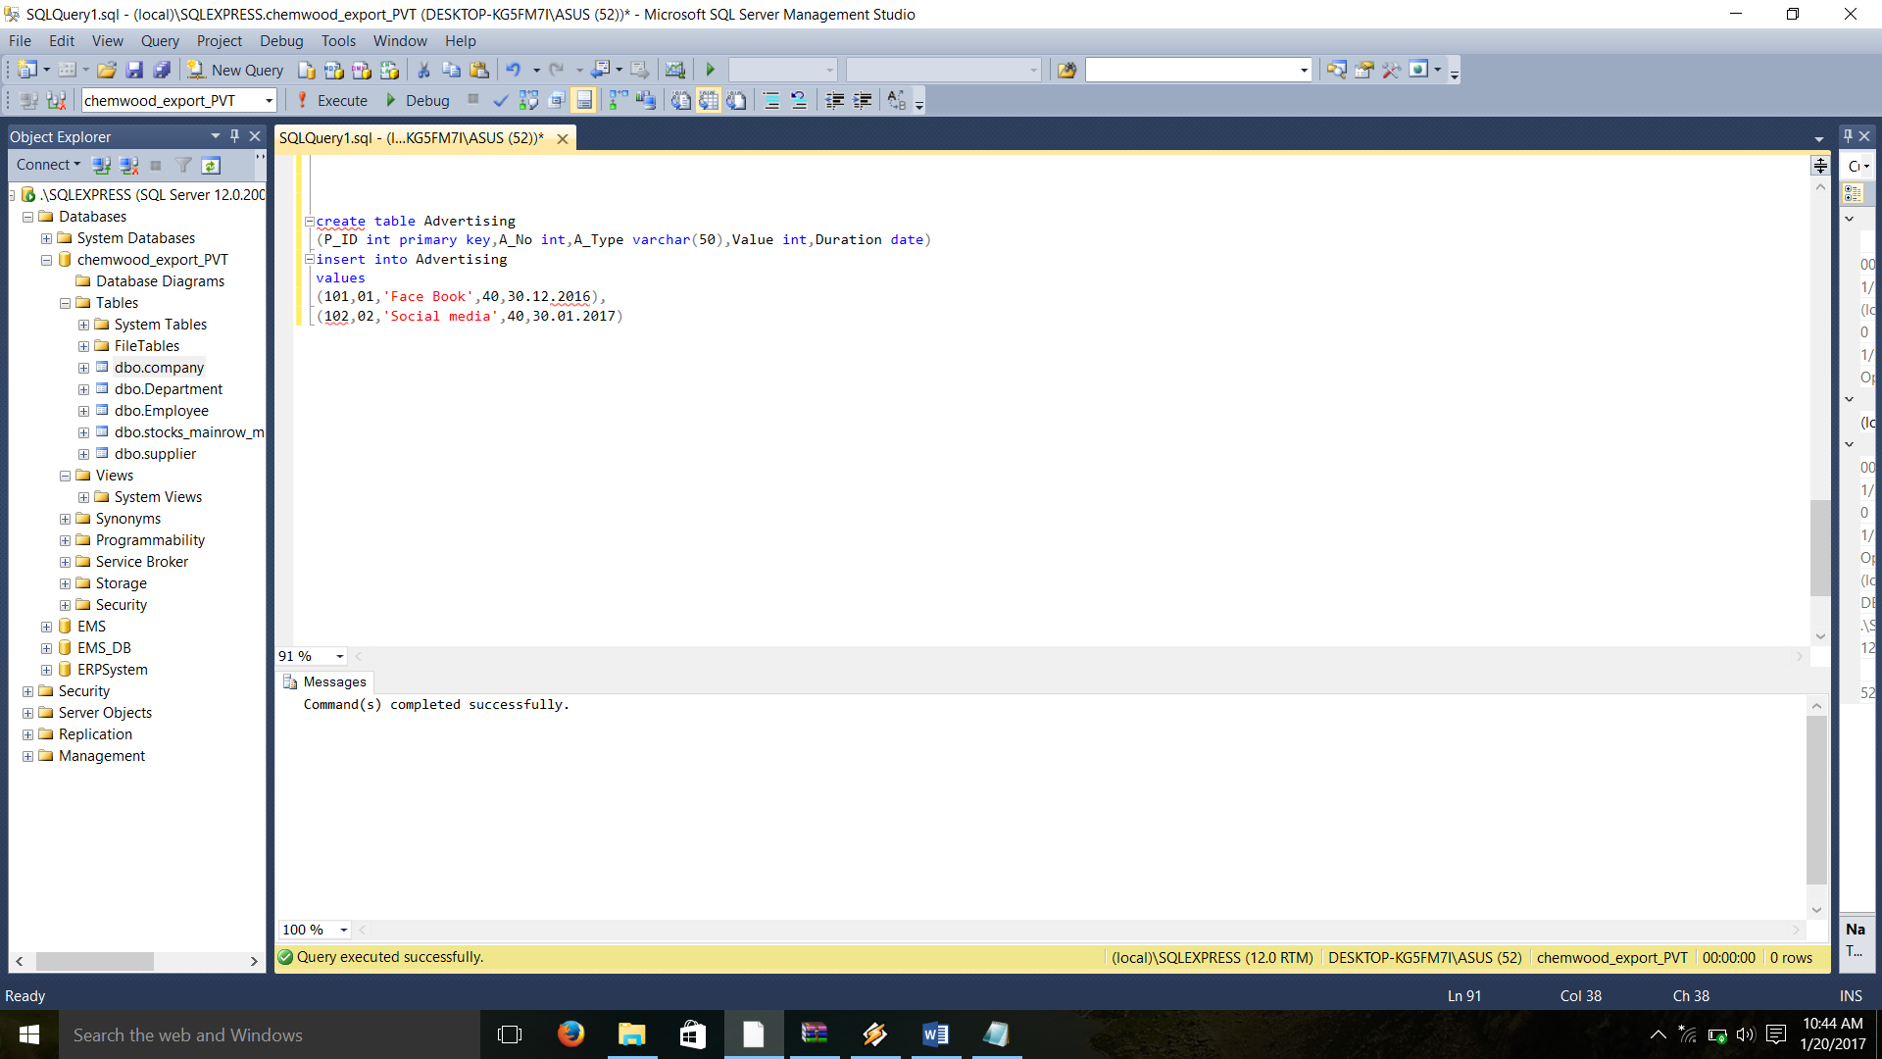Advertisement

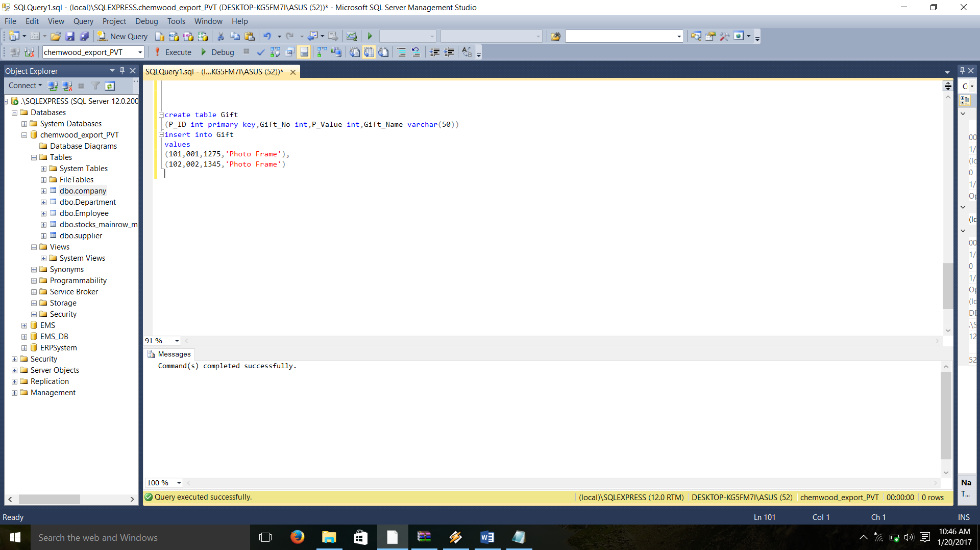8.Gift Table

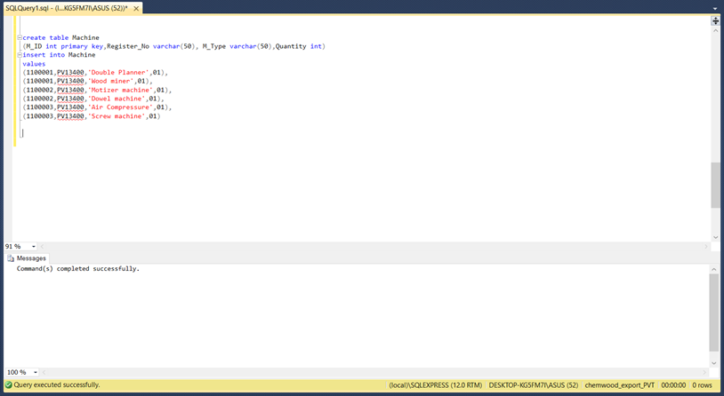9. Machine

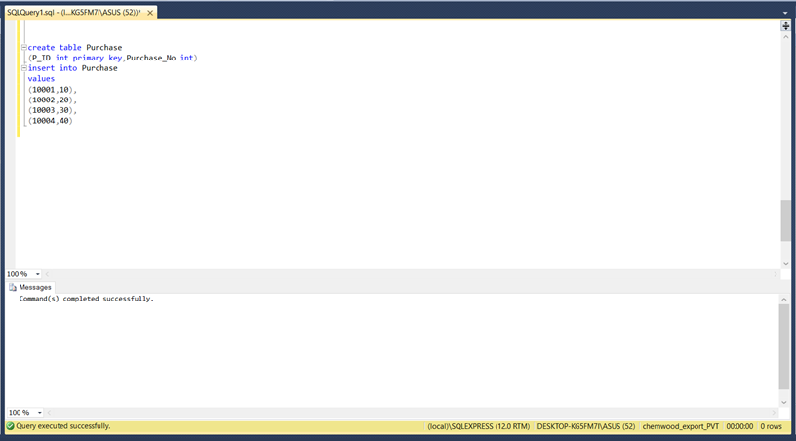10. Purchase

1. 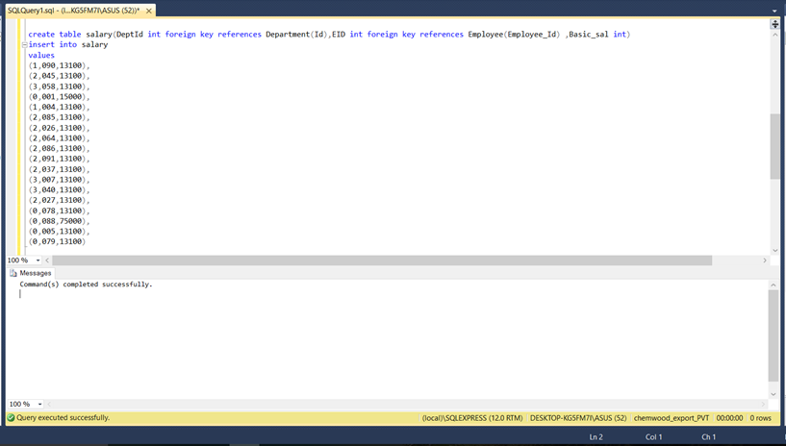Salary

**12. MAPPING ENTITY AND RELATIONS WITH ASSEMTIONS**

**has**

1 m

**Employee**

**Company**

m

1

**Manage**

These are 1 to many partial relationships.

Company has many employees.

Company manage by one employee.

1 1

**Office**

**has**

**Company**

This is a 1 to 1 partial relationship.

Company has one office .

m 1

**control**

**Office**

**Employee**

This is a m to 1 relationship.

Many employees controls the office.

1 m

**has**

**Department**

**Office**

This is a 1 to many relationship

Office has 3 departments.

1 1

**store**

**office**

**store**

This is a 1 to 1 relationship

Office has 1 store.

1. m

**Promotion**

**does**

**Company**

This is a 1 to 1 relationship

Company does many promotions.

supplier

m m

1

supplyy

company

m

good

This relation have all type of relationships

**Order**

m 1

**Company**

**place**

1 m

**Customer**

m 1

**Item**

This relation have all type of relationships

1. m

**handle**

**Payment**

**Company**

Company handles many payments.

This is a 1 to many relationship

1. m

**Company**

**has**

**Machine**

This is a 1 to many relationship

Company has many machines.

|  |  |  |  |  |  |
| --- | --- | --- | --- | --- | --- |
| ***On Schedule*** | | | | | |
| **Planned Finish Date** | **Actual Finish Date** | **Variance**  **(in days)** | **On Schedule** | **Ahead of Schedule** | **Behind Schedule** |
| 30-10-2016 | 28-10-2016 | none |  |  |  |

**Project Completion.**